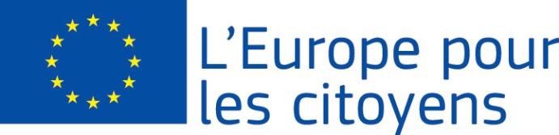
Európa pre občanov

Projekt „Společně pro Europu – Dny obce Milotice“ financovala Európska únia v rámci programu Európa pre občanov
Platí pre 2.1 "Opatrenie pre družobné partnerstvá miest"
Participation: the implementation of the project enabled the meeting of more than 700 citizens. From the home municipality and its surrounding areas it was 520 citizens, from the town of Bánovce nad Bebravou in Slovakia there were 90 participants and also 90 participants came from the town of Esztergom in Hungary.

Place / Date: The event took place in the municipality of Milotice in the Czech Republic, in the period from 13/05/2016 to 15/05/2016

Brief description:

The project from its very beginning expressed mutual solidarity and the need for connecting three different EU nations. Its aim was to contribute to the maintenance and development of their traditions and to link generations without social and demographic discrimination. It primarily focused on exploring the participating nations, developing new and strengthening already existing partnerships. It laid emphasis on removing prejudices against minorities, their culture and traditions. It should be emphasized that the implementation of the event primarily developed European awareness of the participants and promoted their appropriate pride in participation in the EU. The project was at its very early beginning designed to close cooperation of all participating parties. The program of the event was created by representatives of all partners. Preparations for the event ranged several months in advance. It reflects the priority of the Europe for Citizens program. Just for this reason its success is based on the implementation of activities which, through culture, sport and above all education and training helped connect citizens and contribute thus to the development of joint discussions on the need for and impact of EU membership. Active participation of citizens in the event is based on the principles of voluntariness and willingness to participate in the presentation of their identity. Through learning about their cultural specifics the event developed awareness of European identity based on common values, history and culture.

The day of 13/05/2016 was dedicated to culture.
The activities of the first day focused on the cultural program. They were marked by the idea of getting to know the culture and traditions of the partner municipalities. The evening entertainment promoted intercultural dialogue, linguistic diversity and variety of the peoples of Europe performing on one stage. The activities encouraged the creation of new partnerships which can develop into friendships that can easily become the basis for future cooperation. It was a light introduction to the event and friendships between the participants were reinforced.

The day of 14/05/2016 was dedicated to EÚ and vine.
The activities of the second day were devoted to lectures on the EU, its policies and results. The participants gained knowledge of the possibilities offered by EU participation. Promotional materials about the EU were also available. Subsequently, the afternoon activities of the second day were of instructive nature. Milotice municipality is among the most important wine-growing regions in the Czech Republic. The pleasant atmosphere was enhanced by the illuminated Baroque castle, in the courtyard of which some of the activities took place. The results of the day were reinforced relations between the participants through wine - as the dominant of the region and the accompanying cultural program.

The day of 15/05/2016 was dedicated to sport and traditions
The accompanying program of the final day focused on the presentation of the talents of all generations and promotion of healthy lifestyle from an early age. The activities highlighted and promoted the integration of groups difficult to access in the project. After lunch, the self-government representatives were given space for discussions and expressing opinions and ideas about the shift of the arising partnerships.
The self-government representatives discussed the possibilities of extending their partnership with the admission of new members from other EU countries, shifting the partnership onto new levels. The partners are looking forward to the realization of similar, new events. Based on the positive experience with the Europe for Citizens program we want to thank the European Commission for their support of our project and we hope that you will support our future applications for financial support within the program.

